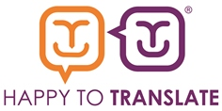
Star Individual Nomination Form

This award will celebrate someone who has demonstrated a strong commitment to promoting and embedding HTT within their organisation.
In less than 500 words, please let us know:
- What did this person do in 2018/19 that helped promote/improve inclusive communication?
- What impact has it had and how has it been measured?
- What cultural change (if any) within the organisation as a result.

Please submit by 30th August 2019.

The winner will be announced at the Members’ Event on 2nd October 2019.

Name:
Role:
Organisation:
Please tell us why someone in your organisation deserves to be Happy to Translate Star Individual for 2019. (Up to 500 words)

