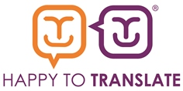
Star Member Organisation Nomination Form

Does your organisation deserve to be Happy to Translate Star Member for 2019? Please tell us why in less than 500 words.

In your response, you should consider:

- how your organisation has utilised Happy to Translate tools and processes to improve communication with those who face a language barrier

- how Happy to Translate has had a positive impact on service delivery. Please provide a real-life example of a project, initiative or scenario.

You may find it helpful to reflect one or more of the Happy to Translate 7 Key Commitments within your response.

https://www.happytotranslate.com/our-members/key-commitments

We wish you luck and look forward to receiving your nomination!

Please submit by 30th August 2019.

The winner will be announced at the Members’ Event on 2nd October 2019.

Name:
Role:
Organisation:
Please tell us why your organisation deserves to be Happy to Translate Star Member for 2019. (Up to 500 words)

